 Transaction Approval Rules

Investigation Exercise

1. Follow these instructions to create transactions that require approval.

a. Log on to ClaimCenter as Betty Baker. She is an auto adjuster. Using the quick claim wizard, create a new personal auto claim using the policy issued to Larry Gamney. Use "Rollover" as the loss cause, and assign the claim to yourself.

b. Create an exposure using "Medical Payments - Medpay" for the insured.

c. Create two reserve lines simultaneously for the exposure:
- Claim Cost - Medical - $10,000
- Claim Cost – Unspecified Cost Category - $10,000

(When you click Save on the Set Reserve screen, you may get a validation warning. You can ignore it.)

2. The transactions require approval. How would an end user know this?

3. What is the reason the transactions require approval? How would an end user be able to determine this?

4. Do the two transactions belong to the same transaction set? Where in the user interface can you go to verify this?

5. Who is responsible for providing approval? What is the ruleset and rule name that assigned this approval request to this individual?

6. Log onto ClaimCenter as the person who is supposed to approve the transactions. Is it possible to approve one reserve and reject the other? What is it about the user interface that makes this possible or impossible?

Configuration Exercise

Configure ClaimCenter to meet the following customer requirement from Acme Insurance.

Requirement 1: Approval for Reserves on "Coverage in Question" Claims

In some cases, a policy holder reports a loss to Acme Insurance, but initially there is a question about whether or not the policy covers the loss. Typically, the claim is created, but the "Coverage in Question" field is set to yes, and one of the early steps of claims processing is for the adjuster to determine if the loss is covered.

Acme's business policies let adjusters create reserves on claims where coverage is in question, but the reserve requires approval.

7. Create the rule(s) needed to enforce these behaviors:
- Any reserve transaction on a claim with coverage in question requires approval by the group supervisor.

8. The ClaimCenter implementation team has provided additional notes:
- The reason for the approval should be "Reserve on claim with coverage in question."

Test Cases: Requirement 1

When you have completed your configuration, run the following test case:

9. Log on to ClaimCenter as Betty Baker and create a new claim. Set the Coverage in Question field to yes (as shown below).

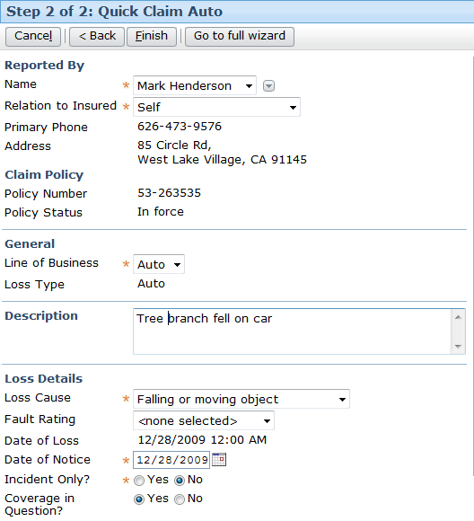

10. Create a reserve on the claim. Verify that the reserve transaction is set to "Pending approval". Also, verify that the approval activity has been routed to the supervisor of the group the claim is assigned to.

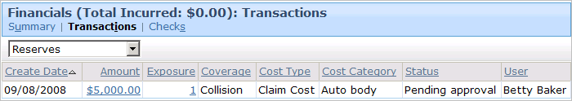

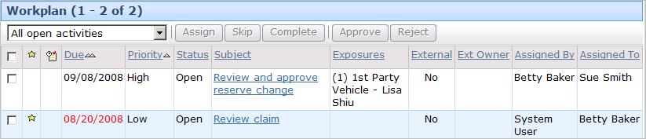

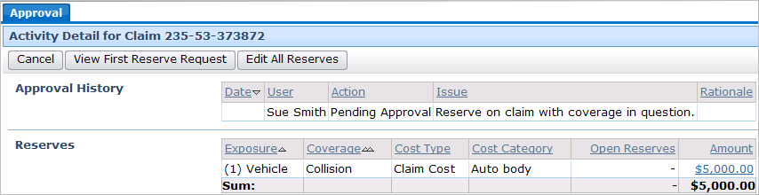

Requirement 2: Approval for Year-Old Supplemental Payments

A supplemental payment is a payment issued against a closed exposure. It is not uncommon for a supplemental payment to occur shortly after an exposure is closed. For example, an injury exposure might issue a payment of $7000, but the doctor determines that the initial treatment should be followed by a secondary procedure. In this case, a supplemental payment could be issued against the exposure for the second procedure.

At Acme Insurance, it is highly unusual for a supplemental payment to occur a year after the exposure is closed, though it does occur occasionally - particular for injuries whose long-term impact is not known when the claim is processed. Consequently, Acme wants to allow supplemental payments against exposures closed for a year or more, but these payments require approval by the group supervisor.

11. Create the script parameter named SupplementalPaymentMaxDays, whose initial value is 364. Deploy your script parameter.

12. Create the rule(s) needed to enforce these behaviors:
- Any payment transaction needs approval if the payment type is supplemental and the transaction date is more than SupplementalPaymentMaxDays after the date the exposure was closed.

13. The ClaimCenter implementation team has provided additional notes:
- To determine the transaction's date, use the TransactionDate field. This field has different meanings for different types of transactions. Consult the data dictionary for clarification on what it means for payments.
- The reason for the approval should be "Supplemental payment on exposure closed for over X days.", where X is the value of SupplementalPaymentMaxDays.

Test Cases: Requirement 2

When you have completed your configuration, run the following test case:

14. To simplify testing to the rules, log on to ClaimCenter as su. Reset the value of the Supplemental script parameter to -1. (This lets you test the rule without having to find an exposure which was closed over a year ago.)

15. Log on to ClaimCenter as Andy Applegate. Navigate to a claim.

16. Create an exposure, then create a reserve line on the exposure. Because supplemental payments are only permitted after a normal payment has been made, make a payment on the exposure and then close the exposure.

17. Make a payment on the claim using the reserve line you just created. Because the exposure is closed, the payment wizard forces you to make the payment supplemental.
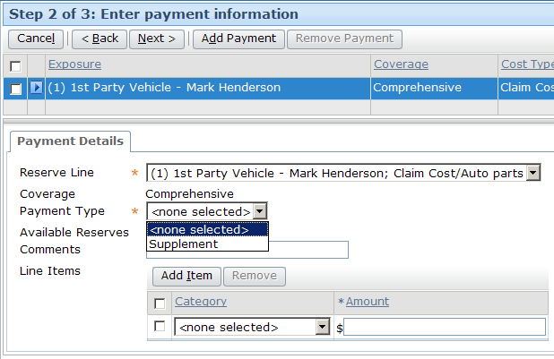

18. Verify that the payment requires approval, that the approval activity has been routed to the group supervisor, and that the issue for approval is correctly specified.
